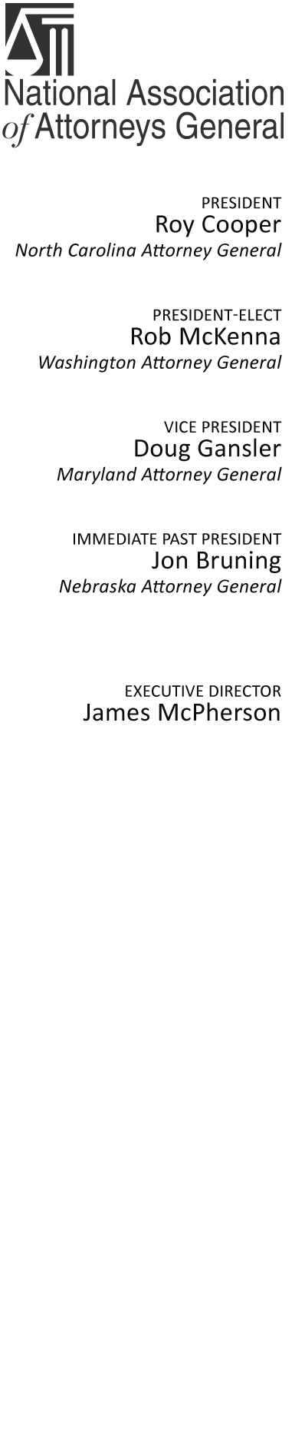

2030 M Street, NW
Eighth Floor
Washington, DC 20036
Phone: (202) 326-6000
http://www.naag.org/

October 13, 2010

JOINT STATEMENT OF THE MORTGAGE FORECLOSURE
MULTISTATE GROUP

It has recently come to light that a number of mortgage loan servicers have submitted affidavits or signed other documents in support of either a judicial or non-judicial foreclosure that appear to have procedural defects. In particular, it appears affidavits and other documents have been signed by persons who did not have personal knowledge of the facts asserted in the documents. In addition, it appears that many affidavits were signed outside of the presence of a notary public, contrary to state law. This process of signing documents without confirming their accuracy has come to be known as “robo-signing.” We believe such a process may constitute a deceptive act and/or an unfair practice or otherwise violate state laws.

In order to handle this issue in the most efficient and consistent manner possible, the states have formed a bi-partisan multistate group to address issues common to a large number of states. The group is comprised of both state Attorneys General and the state bank and mortgage regulators. Currently 49 state Attorneys General have joined this coordinated multistate effort. State bank and mortgage regulators are participating both individually and through their Multistate Mortgage Committee, which represents mortgage regulators from all 50 states. Through this process, the states will attempt to speak with one voice to the greatest extent possible. At the end of this statement is a list of the participating states.

Our multistate group has begun inquiring whether or not individual mortgage servicers have improperly submitted affidavits or other documents in support of foreclosures in our states. The facts uncovered in our review will dictate the scope of our inquiry. The Executive Committee is comprised of the following Attorneys General Offices: Arizona, California, Colorado, Connecticut, Florida, Illinois, Iowa, New York, North Carolina, Ohio, Texas, and Washington; and the following state banking regulators: Maryland Office of the Commissioner of Financial Regulation, New York State Banking Department, and the Pennsylvania Department of Banking.

Participating Attorneys General

Alaska
Arizona
Arkansas
California
Colorado
Connecticut
Delaware
Florida
Georgia
Hawaii Department of the Attorney General / Hawaii Office of Consumer Protection
Idaho
Illinois
Indiana
Iowa
Kansas
Kentucky
Louisiana
Maine
Maryland
Massachusetts
Michigan
Minnesota
Mississippi
Missouri
Montana
Nebraska
Nevada
New Hampshire
New Jersey
New Mexico
New York
North Carolina
North Dakota
Ohio
Oklahoma
Oregon
Pennsylvania
Rhode Island
South Carolina
South Dakota
Tennessee
Texas
Utah
Vermont
Virginia
Washington
West Virginia
Wisconsin
Wyoming

Participating State Bank and Mortgage Regulators

Arizona Department of Financial Institutions
Arkansas Securities Department
Connecticut Department of Banking
D.C. Department of Insurance Securities and Banking
Florida Office of Financial Regulation
Idaho Department of Finance
Illinois Secretary of Financial and Professional Regulation
Indiana Department of Financial Institutions
Iowa Division of Banking
Kentucky Department of Financial Institutions
Louisiana Office of Financial Institutions
Maine Bureau of Consumer Credit Protection
Maine Bureau of Financial Institutions
Maryland Office of the Commissioner of Financial Regulation
Division of Banks, Commonwealth of Massachusetts
Michigan Office of Financial & Insurance Regulation
Minnesota Department of Commerce
Mississippi Department of Banking and Consumer Finance
Montana Division of Banking and Financial Institutions
Nebraska Department of Banking and Finance
Nevada Financial Institutions Division and Mortgage Lending Division
New Hampshire Banking Department
New Jersey Department of Banking & Insurance – Office of Consumer Finance
New York Department of Banking
North Carolina Commissioner of Banks
North Dakota Department of Financial Institutions
Ohio Division of Financial Institutions
Oregon Department of Consumer and Business Services – Division of Finance
and Corporate Securities
Pennsylvania Department of Banking
Rhode Island Department of Business Regulation - Division of Banking
South Carolina Department of Consumer Affairs
Tennessee Department of Financial Institutions
Texas Department of Banking
Texas Finance Commission and Consumer Credit Commissioner
Vermont Department of Banking, Insurance, Securities and Health Care Administration
Washington State Department of Financial Institutions
West Virginia Division of Banking
Wisconsin Department of Banking
Wyoming Division of Banking

